GUIDE TO USE DJANGO
For more detail, refer to
- You should learn from this site: https://www.geeksforgeeks.org/django-tutorial/
- https://www.w3schools.com/django/index.php
INSTALL DJANGO & CREATE PROJECT
========================================================
INSTALL DJANGO (in virtual environment)
Step 1: Python install: https://www.python.org/downloads/
Step 2: C:>\pip install Django
CHÚ Ý: CÀI TỪ C:>\ nếu không hay xảy ra lỗi!
CREATE PROJECT & APP
Step 1: django-admin startproject que_project1 (replace que with YOUR NAME)
/* C:>\cd que_proj1, dir to view what inside the directory
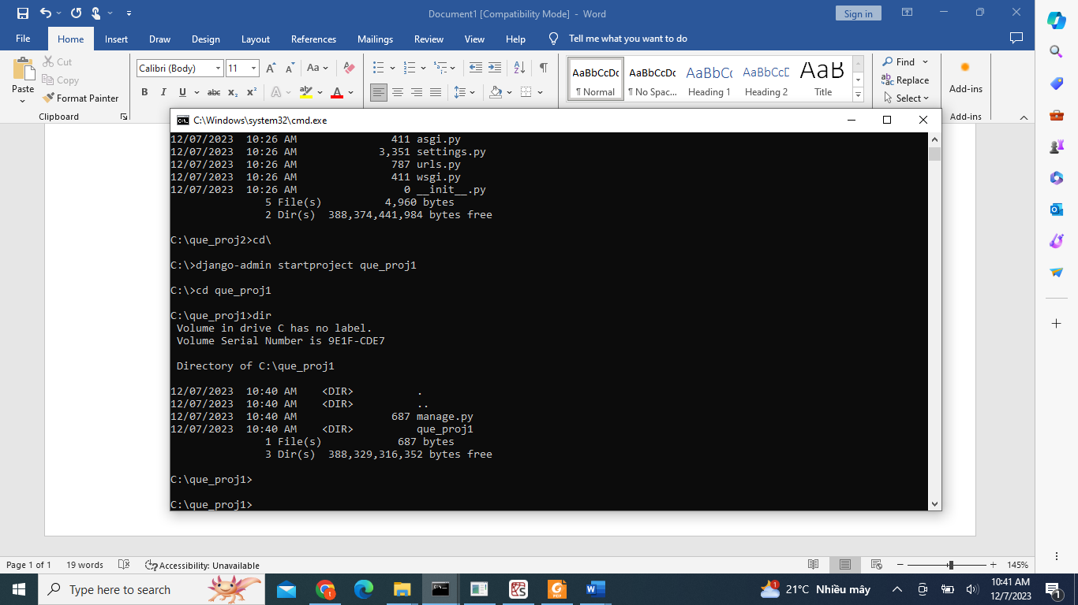
You can type cd que_proj1 to view what inside que_proj1
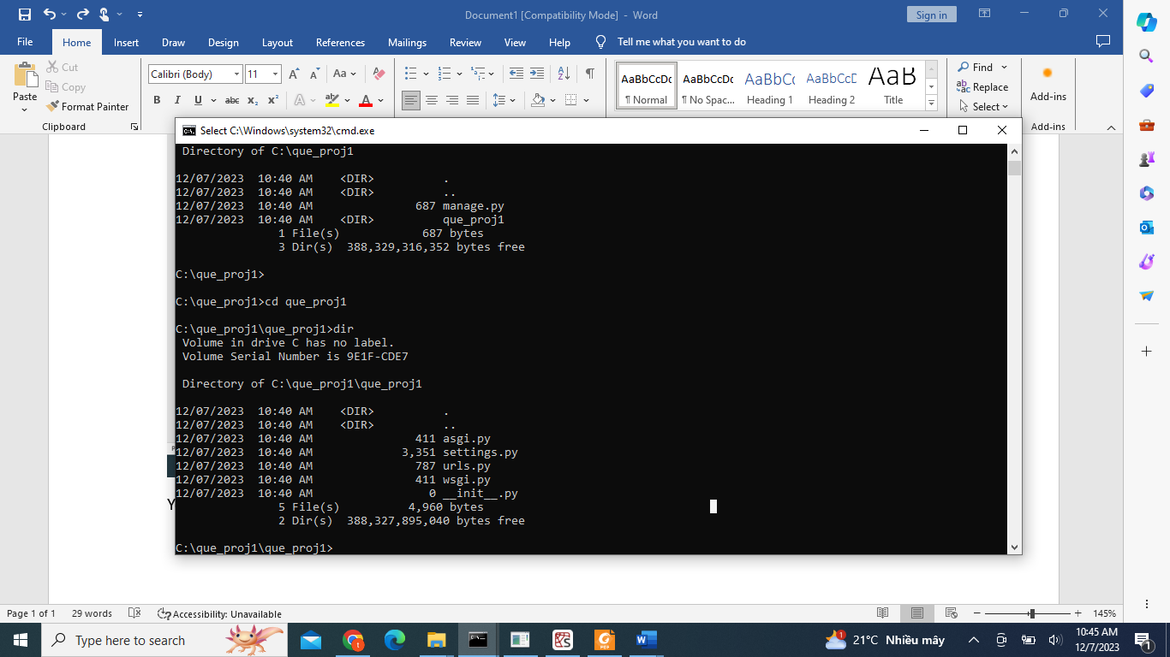
Step 2: Check
C:>\cd que_proj1
C:|>\que_proj1\python manage.py runserver
//copy the link appeared: http://127.0.0.1:8000/ and you will see
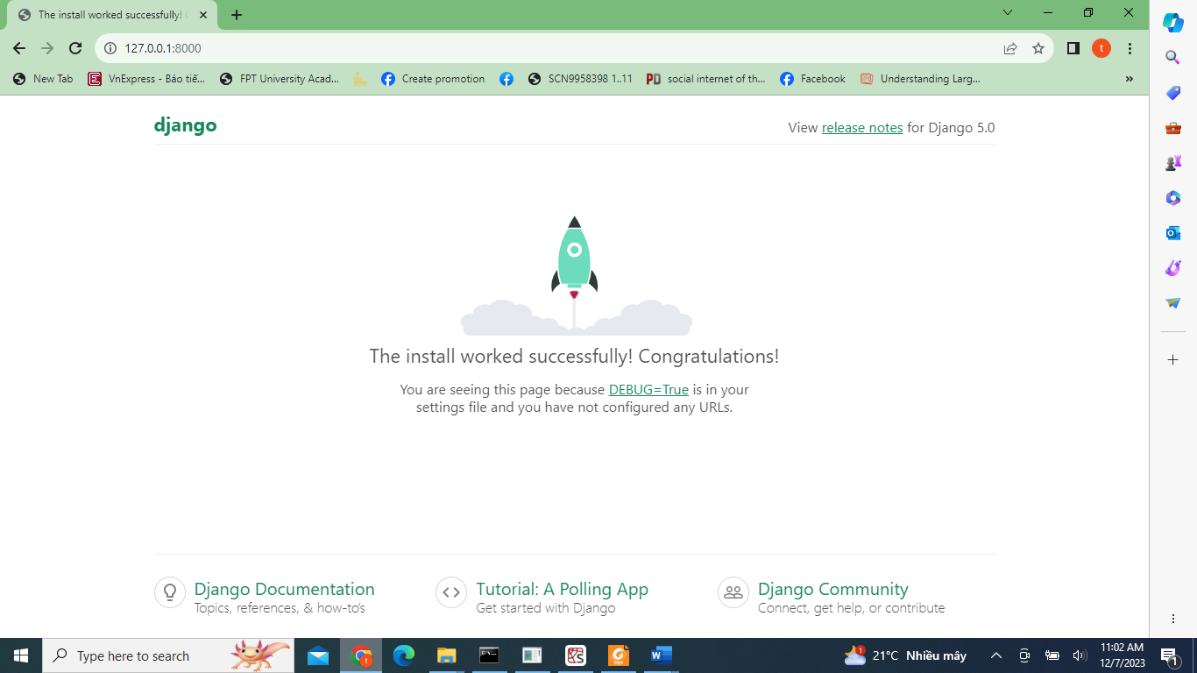
Please open files settings.py, urls.py to view what has been defined so that you develop codes there.
Test Django Database Connection and Build Django Base Tables
C:>\que_proj1\python manage.py migrate
CREATE APPLICATION
C:>\que_proj1\que_proj1\django-admin startapp customer, cart, book
/* create an application named

